|  |
| --- |
| HCCOMP2, HCCOMPE2, BSHC2, BSHCE2, BSHTM2 |
| Requirements Specification (RS) |
| Team Project Market Live |

**<Academic Year 2023/2024>**

**<Eskandar>, <23137517>, <x23137517@student.ncirl.ie>**

**<Alex>, <22440482>, <x22440482@student.ncirl.ie>**

**<Joshua>, <23153920>, <x23153920@student.ncirl.ie>**

**<Yonas>, <23154454>, x23154454@student.ncirl.ie**

**Table of Contents**

1 Introduction 4

1.1 Purpose 4

1.2 Project Scope 4

1.3 Definitions, Acronyms, and Abbreviations 4

2 User Requirements Definition 4

3 Requirements Specification 4

3.1 Functional requirements 4

3.1.1 Use Case Diagram 5

3.1.2 Requirement 1 <name of requirement in a few words> 5

3.1.3 Requirement 2 <name of requirement in a few words> 6

3.2 Non-Functional Requirements 7

3.2.1 Performance/Response time requirement 8

3.2.2 Availability requirement 8

3.2.3 Recover requirement 8

3.2.4 Robustness requirement 8

3.2.5 Security requirement 8

3.2.6 Reliability requirement 8

3.2.7 Maintainability requirement 8

3.2.8 Portability requirement 8

3.2.9 Extendibility requirement 8

3.2.10 Reusability requirement 8

3.2.11 Resource utilization requirement 8

4 GUI 8

5 System Architecture 8

6 System evolution 8

# Introduction

This document will discuss about requirements and specifications detailing the most possibilities, which will be detailed by the team knowing that each team member did their part on the document. This document is subject to change if the team decides to make modifications/changes to the product.

## Purpose

The purpose of this document is to set out the requirements for the development of [Market-Live-Crypto-Prices](https://github.com/EskandarAtrakchi/Market-Live-Prices-Team-Project) to provide people who are interested in cryptocurrencies a platform where they can track the cryptocurrency prices, IDs of the crypto coins/tokens, fear and greed indexes of the whole market, and provide individuals to share their opinions about the crypto market and read other peoples' opinions as well.

this document also sets out the requirements for developing a website that gives a service/ function of checking the price of any cryptocurrency such as Bitcoin, Tether, Solana, Cardano …etc. users will benefit from this functionality because the price/Value of the cryptocurrency is consistently changing up and down.

## Project Scope

The aim is to create a user friendly website for people to check the prices of the cryptocurrencies, the ID number of the cryptocurrency, symbol of the currency, price (US-Dollar), 24 h volume (US-Dollar), Market Capitalization (US-Dollar), Percent Change (1h), Percent Change (24h), and Percent Change (7d).

Users can know the fear and greed in the market

**Greed = majority of the crypto coins/tokens are going up in value**

**Fear = majority of the crypto coins/tokens are going down in value**

The other purpose is that the users can do the following:

1.share their opinions about the market

2.read other people's opinions

3.have real-time chats and engagements

The intended customers who are people who

1.want to invest in the crypto market or trade it

2. Interested in cryptocurrencies precises and its volatility

3. Interested of small caps alt-coins

4. Wants to read other people's opinions about the market

5. Wants to share their own opinion on the market

6. Wants to do real time chats regarding the crypto currency coins/tokens

7. Interested in the fear and greed index for the whole crypto market

The project scope encompasses the development of a user-friendly website that allows users to track real-time prices of various cryptocurrencies. The website will provide essential information, including current prices in US dollars, 24-hour trading volume, market capitalization, and percentage changes over 1 hour, 24 hours, and 7 days. The scope further includes accommodating a diverse user base, including individual investors, traders, developers, businesses, and those involved in global transactions. This section also details any constraints that were placed upon the requirements elicitation process, such as schedules, costs, or the software engineering environment used to develop requirements.

## Definitions, Acronyms, and Abbreviations

* Cryptocurrency: Digital or virtual currencies that use cryptography for security.
* Fear and Greed Index: An indicator reflecting the prevailing sentiment in the cryptocurrency market.
* US-Dollar: United States Dollar.
* H: Hour
* D: Day
* M: Month
* BTC: Bitcoin
* Crypto Coins: Coins function as a form of money
* Crypto Tokens: can be used for a variety of purposes
* NFA: Not a Financial Advice
* Volume: the traded volume of the currency
* Market cap: the total value of a specific cryptocurrency
* Blockchain: A distributed ledger technology used to secure and verify transactions

Note: Each cryptocurrency has its own acronym, for example BTC stands for Bitcoin, ETH stands for Ethereum and so on knowing that there are cryptocurrencies being created on daily bases, that means there are alot of cryptocurrencies as of June 2023, there are almost 26,000 cryptocurrencies publicly traded [forbes.com](https://www.forbes.com/advisor/au/investing/cryptocurrency/different-types-of-cryptocurrencies-explained/)

# User Requirements Definition

The system targets those who want real-time information without the need for registration or their private details. A feedback mechanism will be implemented to take it fully from user’s perspective and see what the market requires.

Description: Users should be able to receive real-time updates on the prices of selected cryptocurrencies. The system must provide accurate and up-to-date information, including the current market price in US dollars.

Rationale: Individual investors and traders need timely information to make informed decisions. Real-time updates ensure that users have the latest data to react to market changes promptly. The users should be able to retrieve crypto ID numbers with the same name of cryptocurrency from the crypto market. Users can see the frame of crypto bubbles from the webpage.

# Requirements Specification

Feedback: user will be provided to fill a feedback form, the form is easy and straight forward, field for message, attach file button, select options, and submission button.

The system shall fetch and display the current price of the specified cryptocurrency in US dollars, The displayed price shall be updated in real-time, reflecting any changes in the cryptocurrency market.

## Functional requirements

The functional requirements specify the features and capabilities that the system will provide to its users. These requirements focus on the core functionalities related to retrieving real-time cryptocurrency price information and displaying it with relevant details.

1. **Percent Change (1, 24 hours, 7Days)**
   * The system shall calculate and showcase the percentage change in the cryptocurrency's price over the last 1, 24 hours, and 7 days.
   * Users shall be able to view the percentage change trends over the 1, 24 hours, and 7 days.
2. **User Interaction**
   * Users shall be able to select and specify the cryptocurrency for which they want to view real-time price information.
   * The system shall provide an intuitive and user-friendly interface for interacting with cryptocurrency data.
3. **Symbol-based Display**
   * Cryptocurrency prices shall be displayed using symbols or abbreviations for quick recognition (e.g., BTC for Bitcoin, ETH for Ethereum).
   * The symbol-based display shall enhance user understanding and usability.
4. **Error Handling**
   * The system shall incorporate error-handling mechanisms to manage situations where real-time price retrieval fails or encounters issues.
   * Users shall receive clear and informative error messages in such cases.

Finally, the feedback mechanism, one time feedback per user. Taking a scenario of a user wants to submit their feedback, the user will go through the following feedback categories, anonymity option, notification system, and finally feedback submission mechanism.

### Use Case Diagram

Main

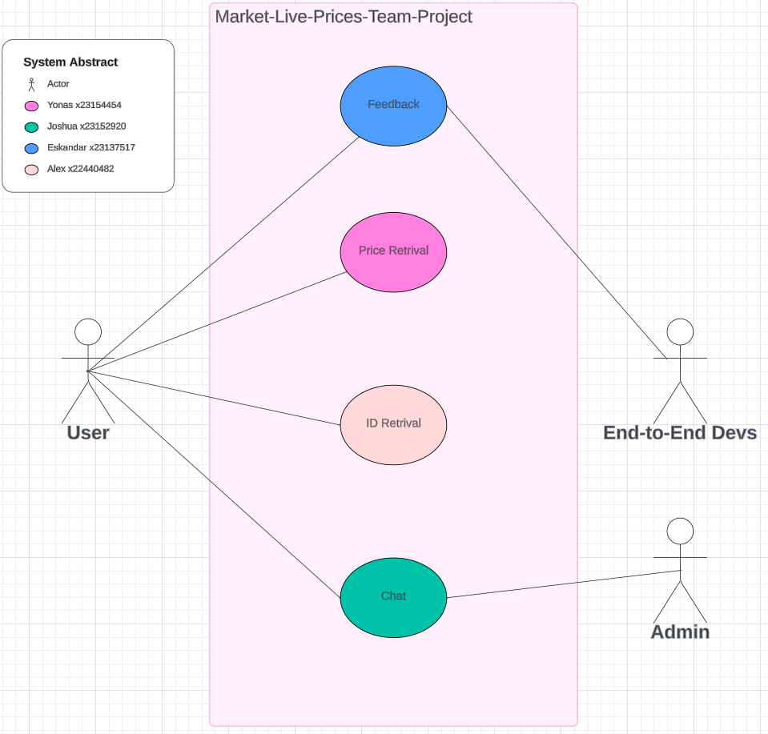

Overall system abstract

FeedBack

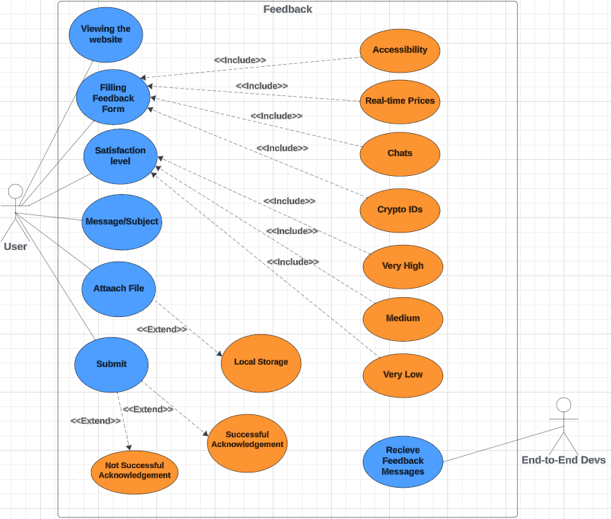

Eskandar Use case Diagram

1. Viewing the website: after the user interacts with the product, they can submit their feedback form.
2. Filling feedback form: the user will be prompt to a form to fill and submit, with in the form the user must choose one of the following categories: Accessibility, Real-time Prices, Chats, and Crypto IDs
3. Message/subject: to fill out a message attached with the feedback.
4. Satisfaction level: the user can select very high, medium, or very low.
5. Attach file: the user will be able to to select a file from their local storage.
6. Submit: the user will submit their feedback and an acknowledgement will be sent

Price Retrieval

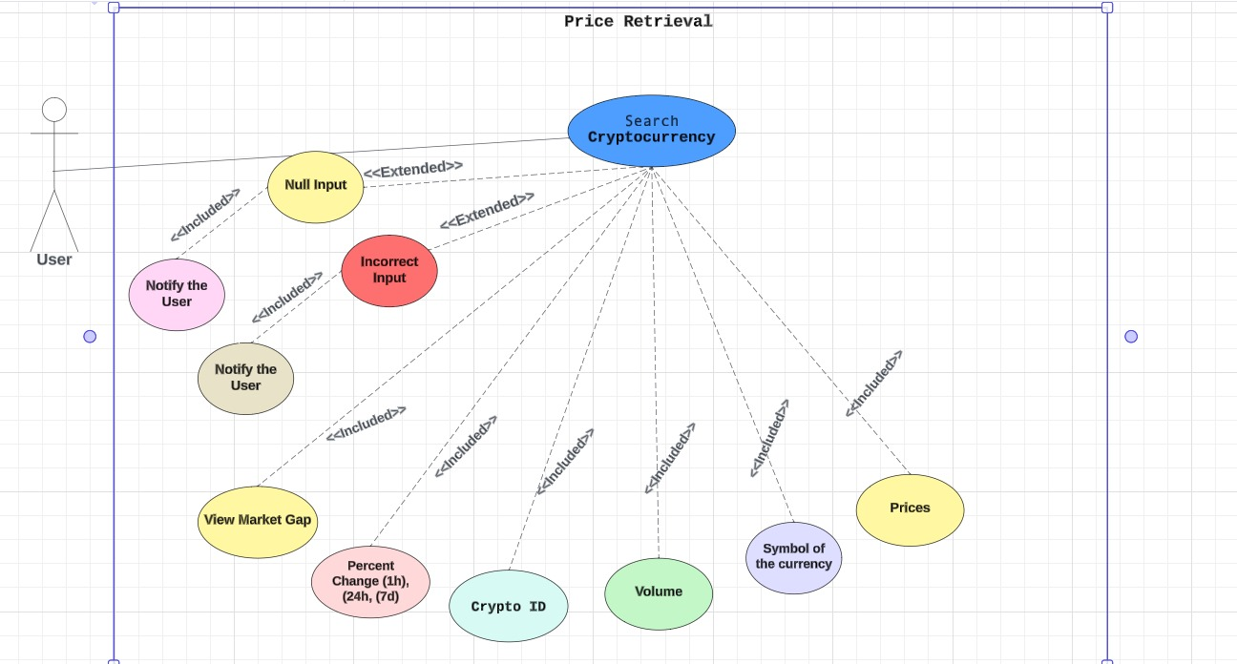

Yonas Use case Diagram

1. The user will interact with the website page to search crypto prices using the name.
2. If the user input null or wrong input the system will inform them to try again with correct information.
3. If the user input correct information the system will fetch the data with expected functionality.

ID Retrieval

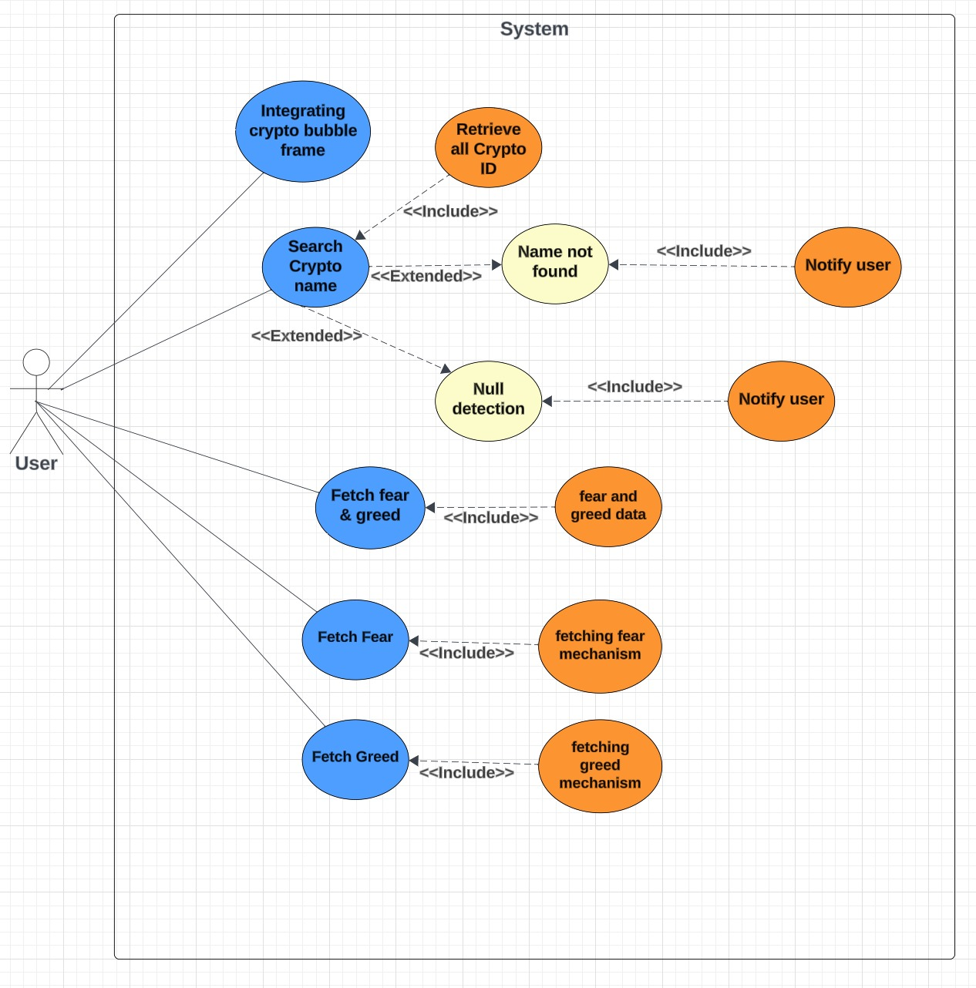

Public Chat

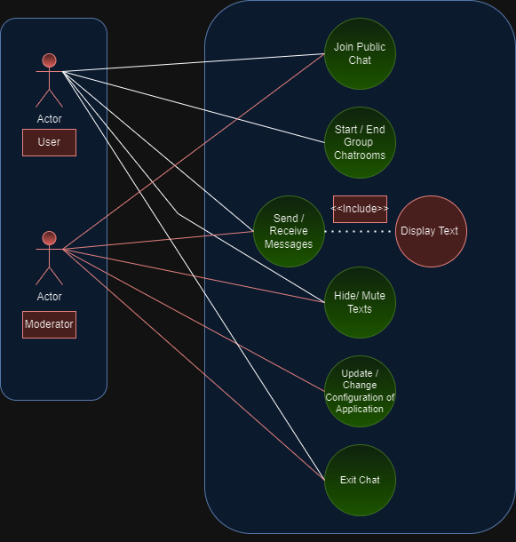

1.User joins public chat.

2.User has an option in starting or ending a group chat (private room) where you can text selected users.

3.User sends and receives messages to other users, which gets displayed. onto the public chat.

4.User can hide text (delete) his own text message if need be.

5.Developer can update, modify, and delete the software of the chat application.

6.User can exit chat.

### Requirement 1 <Crypto ID Retrieval>

The heading of this section should read, e.g., “Requirement 1: User registration” or “Requirements 1: Participant takes test”

#### Description & Priority

A description of the requirement and its priority. Describes how essential this requirement is to the overall system.

#### Use Case

Each requirement should be uniquely identified with a sequence number or a meaningful tag of some kind.

**Scope**

The scope of this use case is to allow users to retrieve the ID number by using API for any cryptocurrency that exists in the crypto market.

**Description**

This use case describes the ID number that refers to the ID listing. For that reason, for any type of cryptocurrency with the same name, all crypto IDs will be retrieved and the bar charts will compare the smaller ID number of the cryptocurrency the higher prices of the currency that we have.

**Flow Description**

**Precondition**

The system is in initialisation mode, ready to receive the ID number from the crypto market

**Activation**

This use case starts when a user enters a textbox to retrieve the ID numbers of a cryptocurrency.

**Main flow**

1. The system identifies the crypto IDs that will be retrieved.
2. The user enters the crypto name in the textbox to retrieve the crypto ID of the cryptocurrency.
3. The system retrieves all crypto IDs that will be associated with cryptocurrency from the crypto market
4. The user receives the crypto IDs from the API system.

**Alternate flow**

A1 : < Crypto Name Not Found>

1. The system fails to find cryptocurrency
2. The user receives an error message
3. The use case continues at position 3 of the main flow

**Exceptional flow**

E1 : <System Error>

1. The system notifies the developers of an unexpected error when the crypto ID is retrieved.
2. The user receives the error message
3. The use case continues at position 4 of the main flow

**Termination**

The system presents the next of crypto IDs with bar charts.

**Post condition**

The system goes into a wait state, ready to process the API to retrieve the data.

### Requirement 2 <Crypto Bubbles>

#### Description & Priority

A description of the requirement and its priority. Describes how essential this requirement is to the overall system.

#### Use Case

Each requirement should be uniquely identified with a sequence number or a meaningful tag of some kind.

**Scope**

The scope of this use case is to integrate cryptocurrency bubbles on the webpage.

**Description**

This use case describes the process of retrieving cryptocurrencies and display the crypto bubbles on the webpage.

**Flow Description**

**Precondition**

The system is in initialization mode using API to retrieve cryptocurrencies.

**Activation**

This use case starts when a user searches for cryptocurrency from crypto bubbles.

**Main flow**

1. The system identifies the API to fetch crypto bubbles.
2. The user integrates with the crypto bubbles.
3. The system retrieves the cryptocurrency data from the API.
4. The user views the crypto bubbles from the webpage.

**Alternate flow**

A1 : <Failed to display>

1. The system fails to display the crypto bubbles on the webpage
2. The user receives an error message.
3. The use case continues at position 3 of the main flow

**Exceptional flow**

E1 : <title of E1>

1. The system notifies the developers of an unexpected error when the crypto bubbles is not displayed on the webpage
2. The user receives the error message
3. The use case continues at position 4 of the main flow

**Termination**

The system presents the next crypto bubbles to the user.

**Post condition**

The system goes into a wait state, ready to process the API to retrieve the data.

### Requirement 3 <Fear and Greed index>

#### Description & Priority

A description of the requirement and its priority. Describes how essential this requirement is to the overall system.

#### Use Case

Each requirement should be uniquely identified with a sequence number or a meaningful tag of some kind.

**Scope**

The scope of this use case is to retrieve the Fear and Greed index from the crypto market.

**Description**

This use case describes the process of displaying the Fear and Greed index on the webpage.

**Flow Description**

**Precondition**

The system is in initialisation mode, the API is ready to retrieve the Fear and Greed index.

**Activation**

This use case starts when a user retrieves the Fear and Greed index chart from API.

**Main flow**

1. The system identifies the API to fetch the Fear and Greed index.
2. The user integrates with the Fear and Greed index.

**Alternate flow**

A1 : <title of A1>

1. The system fails to display the Fear and Greed index on the webpage
2. The user receives the error message.
3. The use case continues at position 3 of the main flow

**Exceptional flow**

E1 : <title of E1>

1. The system notifies the developers of an unexpected error when the Fear and Greed index is not displayed on the webpage
2. The user receives the error message
3. The use case continues at position 4 of the main flow

**Termination**

The system presents the next Fear and Greed index to the user.

**Post condition**

The system goes into a wait state.

### Requirement 4 <User Public Chat>

#### Description & Priority

A description of the requirement and its priority. Describes how essential this requirement is to the overall system.

#### Use Case

Each requirement should be uniquely identified with a sequence number or a meaningful tag of some kind.

**Scope**

The scope of this use case is to provide a user public chat where people can interact and give each other their opinions.

**Description**

This use case describes the public chat that will appear on the website.

**Flow Description**

**Precondition**

The system is in initialisation mode when user enters the website and joins chat.

**Activation**

This use case starts when the user sends a message within the public chat.

**Main flow**

The normal flow

1. The system identifies the user.
2. The user is able to send and receive messages.

**Alternate flow**

What happens if it goes the opposite as intended.

1. The system does not let the user join.
2. The user isn’t able to send messages or receive them.

**Exceptional flow**

1. The system notifies the user of chat errors.
2. The user can restart the webpage/
3. The use case continues at position 4 of the main flow

**Termination**

The system presents the next sent message, or exits the public chat.

**Post condition**

The system goes into a wait state

### Requirement 5 < Price Retrieval >

3.1.1.1 **Description**

Searching crypto data and prices: user will be able to search the cryptocurrency by searching the name of the crypto, and if they user input the correct name of the currency the system will display the crypto data.

### 2 Use Case

**Scope:** The scope of this use case is to enable users to retrieve cryptocurrency data and prices through a search functionality.

**Description:** This use case describes how users can search for cryptocurrency data and prices by entering the name of the cryptocurrency they are interested in. The system will then display the relevant data for the searched cryptocurrency.

**Flow Description Precondition:**  The system is initialized and has access to real-time cryptocurrency data.

**Activation:** This use case starts when a user triggers the search functionality by entering the name of a cryptocurrency.

**Main Flow**

1. The system identifies the user's input as a search query for cryptocurrency data.
2. The system validates the user's input to ensure it matches the name of an existing cryptocurrency.
3. If the user input matches the name of a cryptocurrency:
   * The system retrieves the relevant data and prices for the searched cryptocurrency.
   * The system displays the cryptocurrency data to the user.

**Alternate Flow A1:** If the user input does not match the name of any existing cryptocurrency:

1. The system notifies the user that the entered cryptocurrency name is not recognized.
2. The system prompts the user to enter a valid cryptocurrency name.
3. The use case continues at position 2 of the main flow.

Exceptional flow E1: If there is an error retrieving cryptocurrency data:

1. The system displays an error message indicating that cryptocurrency data could not be retrieved.
2. The system prompts the user to try again later or contact support for assistance.
3. The use case continues at position 2 of the main flow.

### Requirement 6 Feedback

#### Description & Priority

Priority is the lowest however, Feedback mechanism is very important for us to meet the user experience and for system evolution in the future to add more functionalities to the website, feedback will release the product potential if the feedbacks taken seriously.

The environment that we are working on is volatile especially dealing with crypto currencies, attention to user feedback is important.

#### Use Case

After the user view the website, the user can submit their feedback as the following:

1.The user can select the section that they want to submit their feedback form for and the sections are: Accessibility, real-time prices, chats, and crypto IDs

2.Satisfaction level: there are three levels scale and they are: very high, medium, and very low

3.Attach file: if the user wants to attach file from their local device, for example the user can take a screenshot for the meant part and submit it with their feedback process.

4.Subject: the user can write a message if they want to.

5.The team will receive the feedback that was submitted by the user to develop the product accordingly.

**Scope**

The scope of this use case is to provide feedback mechanism for the users to keep developing the system for better user experience and future system evolution.

**Description**

This use case describes the process of collecting and processing feedback from users regarding a particular feature or functionality within the system.

**Flow Description**

**Precondition**

The system is in initialization mode, ready to receive feedback from users.

**Activation**

This use case starts when a user initiates the feedback process.

**Main flow**

1. The system identifies the specific area or feature for which feedback is being provided.
2. The user shares their feedback and provides relevant details.
3. The system processes the feedback, recording relevant information for analysis.
4. The user receives acknowledgment or confirmation of their submitted feedback.

**Alternate flow**

1. The system encounters a specific condition in which additional steps are required.
2. The user follows the specified steps to address the condition.
3. The use case continues at position 3 of the main flow.

**Exceptional flow**

1. The system encounters an exceptional condition that requires special handling.
2. The user follows the prescribed steps to resolve the exceptional condition.
3. The use case continues at position 4 of the main flow.

**Termination**

The system presents the next steps or information relevant to the feedback process to terminate.

**Post condition**

The system transitions into a wait state, ready to receive further feedback.

1. The feedback system should provide a user-friendly interface for input.
2. The system able to capture files and include them with the submission.
3. Feedback of the users will be stored for future system evolution
4. The acknowledgment to the user may include a reference number for tracking purposes.

## Non-Functional Requirements

Non-Functional Requirements mostly for the back-end devs to deal with and in communicate with front-end devs if anything is needed.

Here are what is needed for our project for now:

Performance/Response time requirement

| **Components** | **Explanation** |
| --- | --- |
| Node.js, Express.js | Node.js and express.js used because of their high-performance capabilities and they can handle requests in a very efficient way. |
| Axios.js | Axios.js is used for making HTTP requests and can contribute to optimizing response times. |
| Socket.js | Socket.js can enhance real-time communication performance. |

#### Availability requirement

| **Components** | **Explanation** |
| --- | --- |
| Node.js | contributing to high availability. |
| Express.js | contributing to high availability. |
| Nodemon | Nodemon helps in automatic server restarts, ensuring continuous availability during development. |

#### Recover requirement

| **Components** | **Explanation** |
| --- | --- |
| Nodemon | Nodemon's auto-restart feature can aid in quick recovery during development |
| Express.js | with proper error handling, can contribute to a robust recovery mechanism. |

#### Robustness requirement

| **Components** | **Explanation** |
| --- | --- |
| Nodemon | Nodemon's auto-restart feature can aid in quick recovery during development |
| Express.js | with proper error handling, can contribute to a robust recovery mechanism. |

#### Security requirement

| **Components** | **Explanation** |
| --- | --- |
| Cors.js | helps in managing Cross-Origin Resource Sharing (CORS), ensuring secure communication between the client and server and this will be used in with socket.io together for creating realtime chat App. |
| Express.js | provides a framework for implementing security measures |

#### Reliability requirement

| **Components** | **Explanation** |
| --- | --- |
| Node.js, Express.js | reliability for handling backend requests |
| Nodemon | automatic restarts contribute to reliable development by quickly recovering from errors. |

#### Portability requirement

| **Components** | **Explanation** |
| --- | --- |
| Node.js, Express.js | are cross-platform, making the application easily portable across different operating systems. |

#### Extendibility requirement

| **Components** | **Explanation** |
| --- | --- |
| Node.js, Express.js | provide a modular and extensible architecture for example, it is easy to add a route by express.js for the front-end |

#### Resource utilization requirement

| **Components** | **Explanation** |
| --- | --- |
| Node.js | providing a non-blocking, event-driven architecture that can handle many simultaneous connections without high resource usage. |
| Express.js | efficient resource utilization in handling HTTP requests. |

# GUI



Feedback page

The navbar is to route the user to other pages, we will include nice footer for the user that includes useful links so that the user can get more information about the markets, all pages are linked as the user can chat about crypto currencies, check the market status or specific currency, chats, and send categorized feedback.

The price retrieval GUI will be designed with a clean and intuitive layout, ensuring ease of navigation for users. It will follow below designs for a positive user experience.

User will search for one or more by names and then the output will be displayed by the table and graph will be shown below this will help the user gain the information along with visual data.



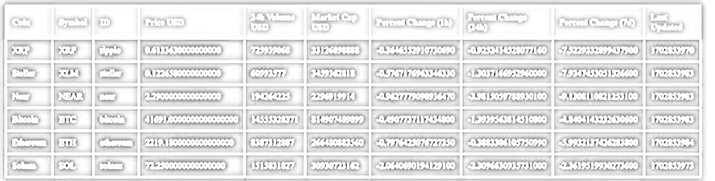

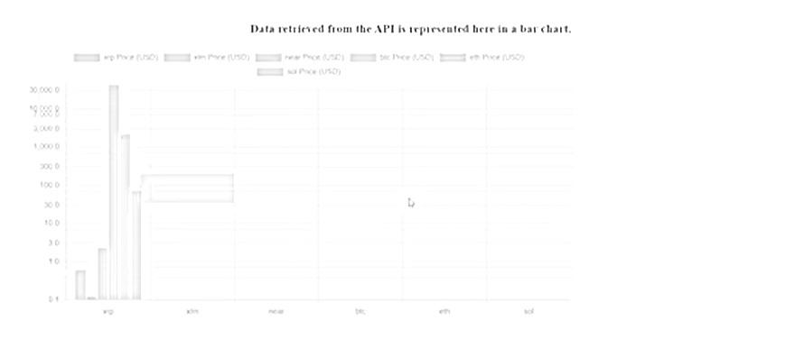

The users can retrieve the ID number for any cryptocurrency that exists in the crypto market. Fear and Greed index of the whole crypto market indicates. Integrating crypto bubbles frame by using API. Users can see the frame of crypto bubbles from the webpage.

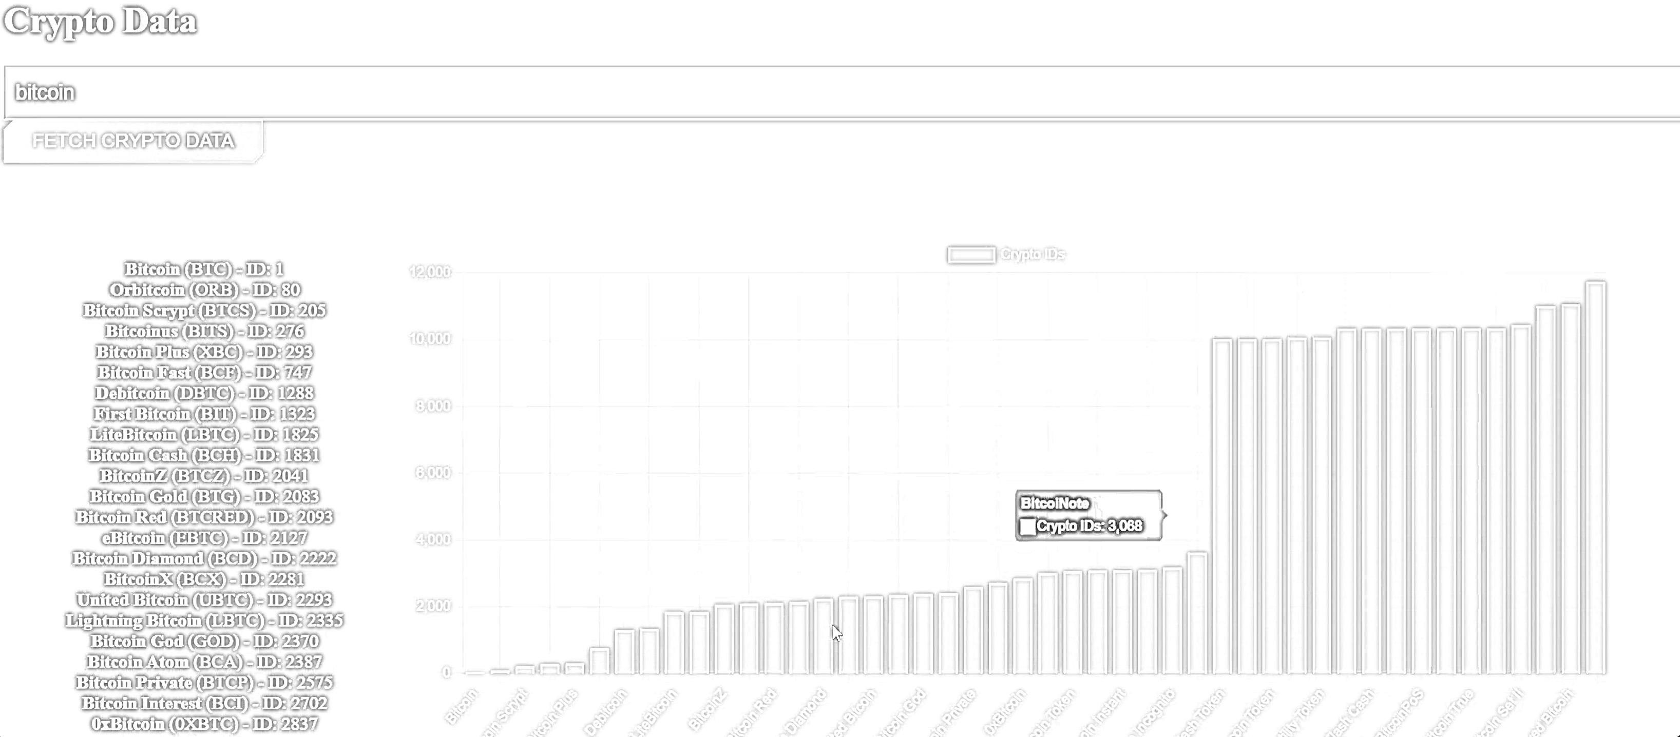

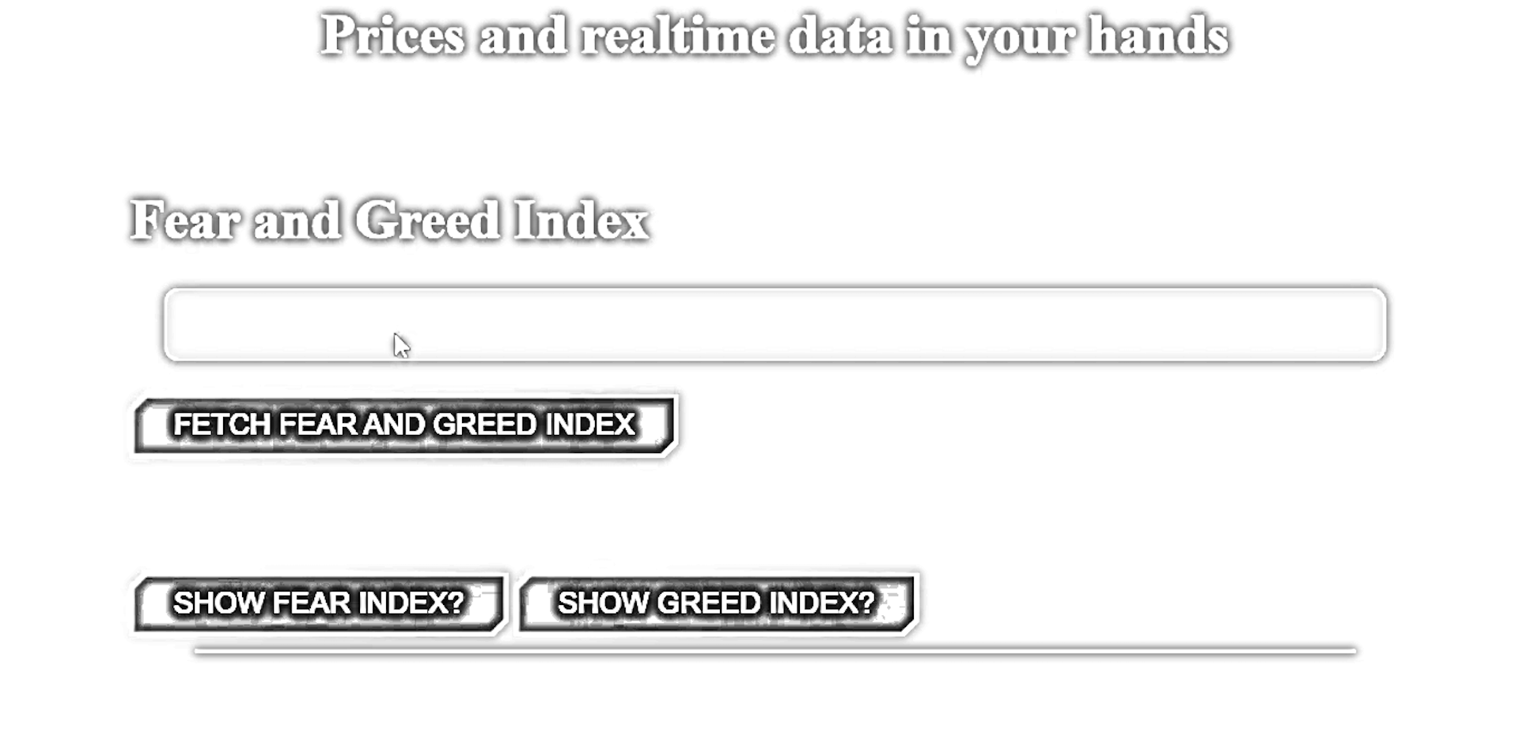

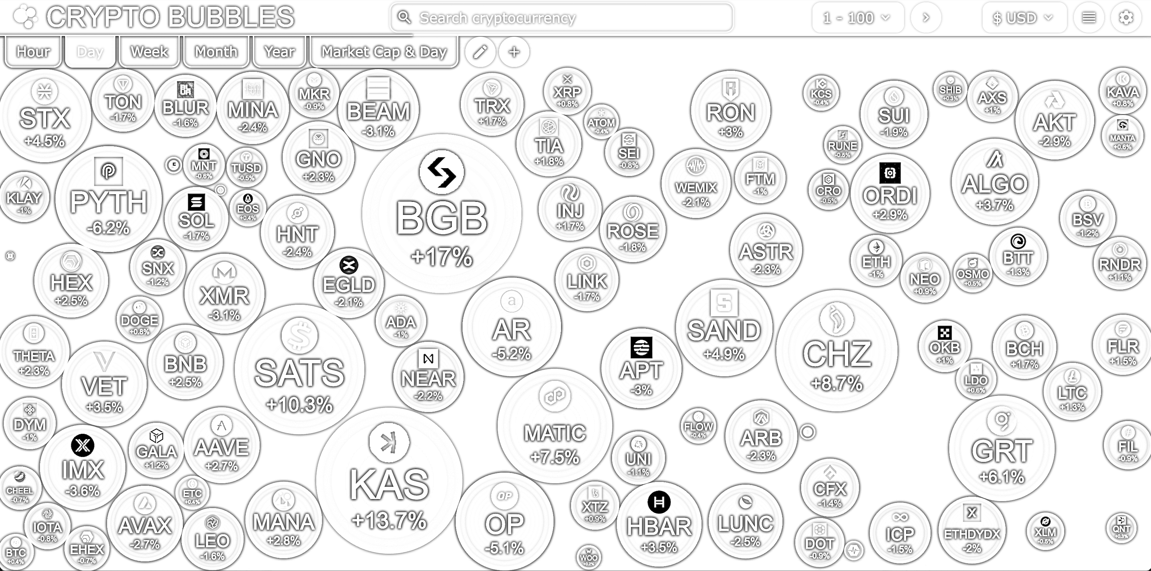

# System Architecture

The hub is back-end server responsible on routes and does the following.

1.if the user is trying to use chat terminal, then the route will direct the user to broadcasting via terminal to all connected devices

2.if the user trying to pull data that requires APIs to execute the condition the API requests route will be directed to the APIs third party providers: this can help to get crypto listings IDs, real-time prices, changes in prices and much more.

3.if the user tries to send feedback the one time condition will be implemented before routing and it works like this: A. if this is the first time that the user sends their feedback then the feedback message will be sent to the hub and an acknowledgement will be sent to the user B. if the user submitted their feedback before then the feedback mechanism system will detect that the user has submitted their feedback before therefore, their feedback will not be send to the hub and an acknowledgement will be sent to the user.

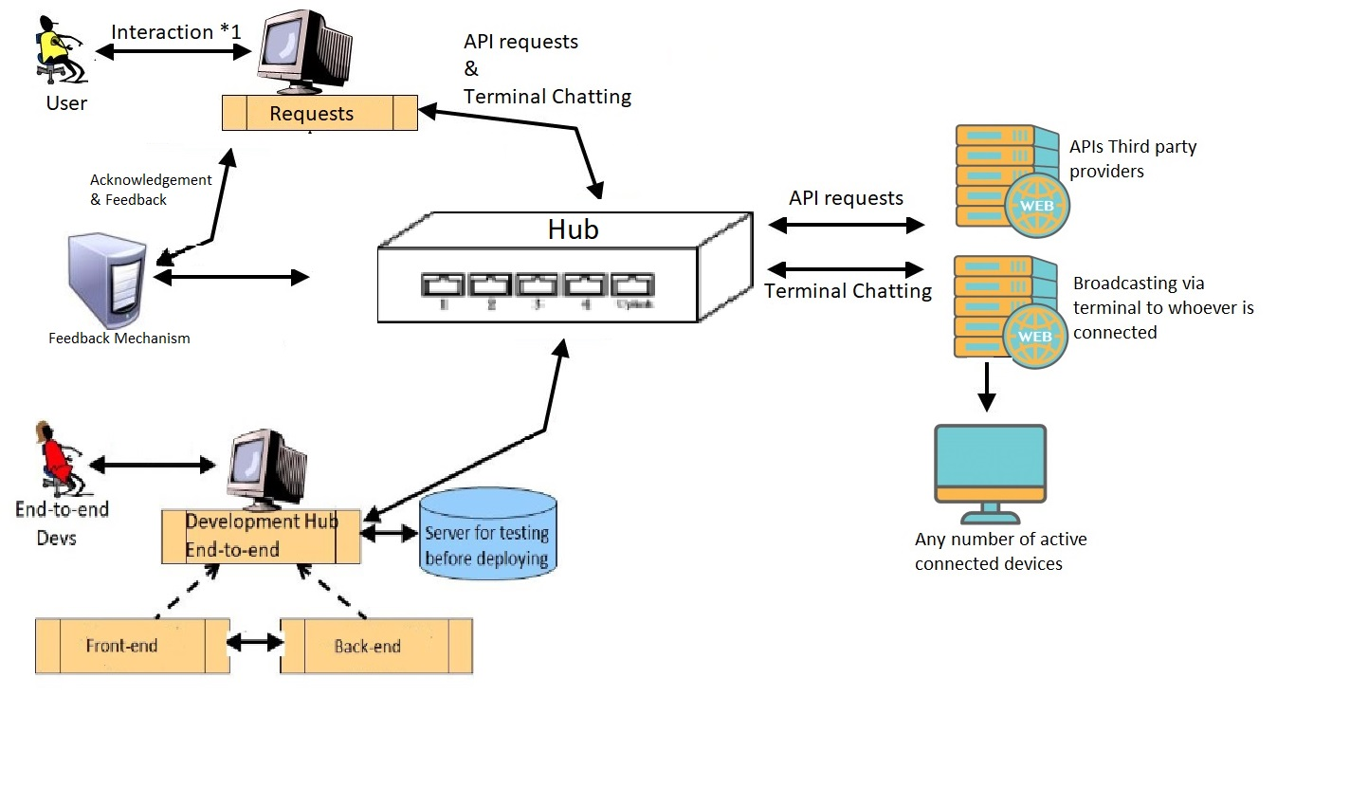

# System Evolution

There are a lot of implementations on the website and they can be done in the future and the team is aware of that, the problem is that this is an evolving environment and it is changing all the time, applying a feedback mechanism will help us to know not only how to implement our ideas in the future, but if our ideas are not useless to the market.

Also, following this mechanism will help us to get new ideas for system evolution to be implemented in the near or far term knowing that feedback page was not mentioned in the proposal, it was decided later specifically for the purpose of system evolution.